Cairo University  
Faculty of Computers and Artificial Intelligent

**CS251 - Software Engineering I**

Project Name

Software Requirements Specifications (SRS)

Team Names

Month & Year

Contents

Instructions [To be removed] 3

Team 3

Document Purpose and Audience 3

Introduction 3

Software Purpose 3

Software Scope 3

Definitions, acronyms, and abbreviations 3

Requirements 4

Functional Requirements 4

Non Functional Requirements 4

System Models 4

Use Case Model 4

Use Case Tables 5

Ownership Report 6

Policy Regarding Plagiarism: 6

# Team

|  |  |  |  |
| --- | --- | --- | --- |
| **ID** | **Name** | **email** | **mobile** |
| 20201020 | Asala Ehab Mohamed | asalaehab824@gmail.com | 01149114891 |
| 20200140 | Habiba Ayman EL tahry | pandatommo@gmail.com | 01121324687 |
| 20200173 | Dina Othman Emam | dinaosman581@gmail.com | 01100725368 |
| 20201014 | Esraa Osama Mohamed | eo6344848@gmail.com | 01123010703 |

# Document Purpose and Audience

Document Purpose:

This file is an explanation of functional and non-functional requirements, a use case diagram and an explanation tables of the use case

Audience:

Garage owner and Entrepreneurs interested in new projects

# Introduction

## Software Purpose

The garage owner is allowed to determine the number of slots and its dimension , the system calculate the time of entry and exit of the vehicle automatically, and calculating the total revenue at any time, The garage owner is allowed to choose the way to park

## Software Scope

1. The system should provide form to the car owner to enter the vehicle information
2. The system should provide form to the garage owner to choose the way to pick a slot
3. The system must provide calculate fees service and display it to the owner of the car
4. The System Must Provide determine the entry and exit time of the vehicle
5. the system must calculates the number of vehicles and Calculate revenue at any time and display it to the garage owner

## Definitions, acronyms, and abbreviations

|  |  |
| --- | --- |
| first come first served | **the garage owner choose first free slot** |
| best-fit approach | **the garage owner choose the slot with the minimum dimension to hold the vehicle.** |

# Requirements

## Functional Requirements.

The garage owner is allowed to determine the number of slots and its dimension , the system calculate the time of entry and exit of the vehicle automatically, and calculating the total revenue at any time, The garage owner is allowed to choose the way to park

1-enter information

It allows the driver to enter his vehicle's data from the model name, model year, vehicle dimensions and vehicle identification number

2- parking

a-park in

pick a free slot is done in two ways

1. Pick the first free slot available from the parking garage slots.
2. Pick the slot with the minimum dimension to hold the vehicle.

b-park out

Calculate fees

c-determine time

Set the entry and exit time

d-calculate

calculates the number of vehicles and Calculate revenue at any time

## Non Functional Requirements

|  |  |
| --- | --- |
|  | **details** |
| Availability | The application is down not more than 5 minutes per week. |
| Performance | The application must support 50 parallel drivers |
| Usability | The number of steps in the application does not exceed 3 steps  And the application allows the driver to change the vehicle information |
| **Security** | The vehicles information is not accessible to anyone |

# System Models

## Use Case Model

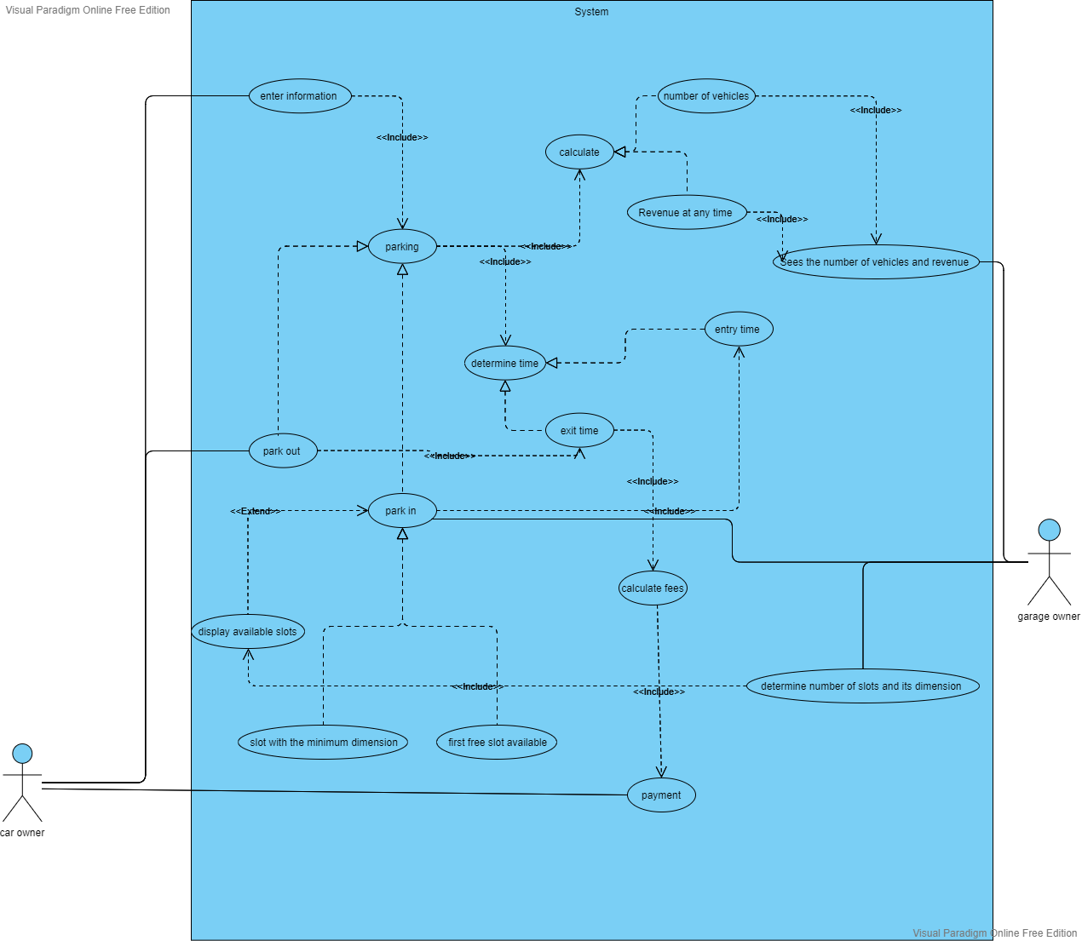

## Use Case Tables

|  |  |  |  |
| --- | --- | --- | --- |
| Use Case ID: | Use case 1 | | |
| Use Case Name: | Enter information | | |
| Actors: | The car owner | | |
| Pre-conditions: | The driver open the application | | |
| Post-conditions: | The parking function will be invoked. | | |
| Flow of events: | **User Action** | **System Action** | |
| 1- the driver open the application |  | |
|  | 1. the application responses   By invoke form which ask him about information about the vehicle | |
| 1. the driver will enter the vehicle information such as the vehicle name ,model year ,identification number and the vehicle dimensions |  | |
|  | حفظ الترجمة  The system will respond by displaying a message indicating the success of the data registration process  And parking function will be invoked. | |
|
| Exceptions: | **User Action** | **System Action** |
| 1-the driver enter the vehicle information such as the vehicle model ,model year ,identification number and the vehicle dimensions |  |
|  | 2- the system invokes message that tell the drivr that there is no available slot and ask him to wait |
| Includes: | Parking | |
| Notes and Issues: | **Security ,** Usability | |

|  |  |  |
| --- | --- | --- |
| Use Case ID: | Use case 2 | |
| Use Case Name: | Park-in | |
| Actors: | garage owner | |
| Pre-conditions: | The park-in function is activated. | |
| Post-conditions: | The slot is chosen. | |
| Flow of events: | **User Action** | **System Action** |
| 1- the garage owner press park-in button. |  |
|  | -2The System will response by show him two options  (first free slot available,slot with minimum dimensions to hold the vehicle )  to select from them |
| 3-garage owner will choose ( slot with the minimum dimension to hold a vehicle) |  |
|  | 4- The system will display the appropriate slots according to the dimensions of the car. |
| 5- The garage owner will choose the slot in which the vehicle will be parked | 6- the system will record the entry time by invoked entry time function |
| Exceptions: | **User Action** | **System Action** |
| 1- The garage owner select a specific configurations and press button . |  |
|  | 2-The system did not find an empty slot according to the dimensions of the car. |
| Includes: | display available slots , entry time | |
| Notes and Issues: | Usability | |

|  |  |  |
| --- | --- | --- |
| Use Case ID: | Use case 3 | |
| Use Case Name: | Calculate | |
| Actors: | The garage owner | |
| Pre-conditions: | The garage owner press the calculate button. | |
| Post-conditions: | The system calculates total income and the total number of vehicles. | |
| Flow of events: | **User Action** | **System Action** |
| 1-The garage owner press calculate button . |  |
|  | 2- The system will respond by show him two options once to calculate the number of vehicles and the total income. |
| 3-The garage owner will select calculate the total vehicles. |  |
|  | 1. the total vehicle function will show the garage owner the total number of vehicles. |
| 4-the garage owner will select to calculate the total income. | 5-The total income function calculates the number of hours each vehicle spent in the slot and then multiplies the number of hours in 5 pounds  It shows the revenue at any time . |
| Exceptions: | **User Action** | **System Action** |
| 1-The owner of the garage pressed the button to calculate the total in come |  |
|  | 2-The program display incorrect revenue |
| Includes: | sees the number of vehicles and revenue | |
| Notes and Issues: | Usability | |

|  |  |  |
| --- | --- | --- |
| Use Case ID: | Use case 4 | |
| Use Case Name: | Park out | |
| Actors: | The car owner | |
| Pre-conditions: | The car leaves the slot | |
| Post-conditions: | The car owner pay the cost . | |
| Flow of events: | **User Action** | **System Action** |
| 1-The driver takes the vehicle out of the slot and press park-out button |  |
|  | 2- The system records the exit time and invoke the exit time function  3-the system calculates the period of parking the car inside the slot  4- the system multiplies the number of parking hours by 5 pounds and then displays the cost to the car owner and the calculate fees function will be invoked |
| 5-The car owner will pay the cost |  |
|  |  |
|  |  |
| Exceptions: | **User Action** | **System Action** |
| 1-The driver takes the vehicle out of the slot and press park-out button |  |
|  | 2- The program will display an incorrect cost of parking |
| Includes: | Exit time , calculate fees | |
| Notes and Issues: | Usability ,security | |

# Ownership Report

|  |  |
| --- | --- |
| **Item** | **Owners** |
| Document Purpose and Audience  Software Purpose  Software Scope  Definitions, acronyms, and abbreviations  Functional Requirements  Non Functional Requirements  Use Case Model  4- Use Case Tables | *Dina Osman emam*  *20200173*  *Habiba ayman eltahry*  *20200140* |
|  |  |

.